**Subscription based chat application (Subscription Model)**

**Submitted To: Saidul Haque**

**Creation Date: 13/06/2022**

**Internship Report**

|  |  |
| --- | --- |
| Group Members | ID |
| Rafid Al Ahsan | 1722006 |
| Maksura Akter Ety | 1820999 |
| Tiasha Swarnaker | 1820874 |

|  |  |  |
| --- | --- | --- |
| Table of Contents | | |
| 1 | Introduction | Page: 03 |
| 2 | Purpose of this internship | Page: 03 |
| 3 | What we have learned so far | Page: 03 - 11 |
| 4 | Final Expected Outcomes | Page: 11 |
| 5 | Conclusion | Page: 11 |

**Introduction**

On March 13, 2020 based on an academic-industrial collaboration between Independent University, Bangladesh and Grameen Communication we started our internship journey.

In 1994, Grameen Communications initially started functioning as a Computer Services Unit under Grameen Trust, providing an automated MIS for Grameen Bank. Grameen Communications believes in quality performance, especially in the field of microfinance both in Bangladesh and abroad. Grameen Communications is a leading IT solutions provider in Bangladesh. With a strong track record in IT solutions development, proven corporate structure, standards and infrastructure, Grameen Communications provides IT solutions and support services to a wide range of users. Being able to work as an intern in reputed and leading IT solution company such as Grameen Communication will give a huge benefit in our carriers.

After starting our internship as software developing intern, we were assigned a task to develop a subscription-based chat application for the internal use of Grameen Communication. The chat applications will enable user to chat with one another using internet service. Later on, were divide into two groups. Our group was assigned to develop the features of the chat application. Features include designing and developing landing page, login page, dashboard, subscription management, payment gateway integration, designing database and backend programming.

**Purpose of this Internship**

The purpose of this internship is so that we the interns can get a flavour of the industry. This internship will help us to further develop our skills and develop new ones. These skills include,

* Learning how largescale projects are managed, developed, and handed over to clients on time
* Getting used to office culture
* Working in teams
* Improving communication skills
* Better time management
* Building a professional network

All these skills will help us in our future career.

**What we have learned so far**

Firstly, after joining our supervisor Saidul Sir assigned us a task in excel sheet. Our task was to write a brief description and syntax of all the technologies used for software development. A screenshot of the excel sheet is provided below. Also this is the link for the excel sheet for all members of the software development team - <https://docs.google.com/spreadsheets/d/1gk6eOnR_PEkJsQmhA7dq_jcWBZO9WTjCgaKukrJr3a4/edit?fbclid=IwAR1LCA0vYHTi8DcVTRulqJJ2ir2RFnjtVSi4WCzWNU0eHzZWfPYFIldxABY#gid=271676484>

This task was a brainstorming for us. Later we were assigned the task for developing and designing the Graphical User Interface of the chat application using HTML5, CSS3, BootStrap5. The screenshot of the graphical user interface is provided below.

After finishing all this work, Saidul Sir assigned us the task to complete the Business Requirement Documents (BRD) for the subscription-based chat application. Each of the software development team members wrote certain sections of the BRD. The link for the BRD - <https://docs.google.com/document/d/1I-qM2Pi51Vsr-bV5PmlkeqfN-yA8tT2XKJaDxS0U7u4/edit?fbclid=IwAR13yZ3UlS6bDWrbFinRCzI_Bj0-orbj5uBqH0oPhFbzKa9T9imPZFQNGPs>

Here is a screenshot of the BRD

After completing the BRD we are asked to learn the front-end frame Vue.js and back-end framework PHP-Laravel framework. We learned how to perform CRUD operations in this framework. Since we didn’t host this project online, we are unable to provide a link. However, few screenshot have been provided below.

After completing this task, we were divided into two groups. Our group was tasked to develop and design the features of the chat applications such as – Landing Page, Login and Sign-up page, Dashboard, Subscription plan management, Payment gateway integration, Designing Database and programming the backend for all features. Here is the process flow diagram

Everything in the subscription model has been design and developed by us. Screenshot of all the pages made by use is provided below

**Landing Page:**

**Login and Sign-Up Page:**

**Dashboard:**

**Subscription Page:**

**Payment Page:**

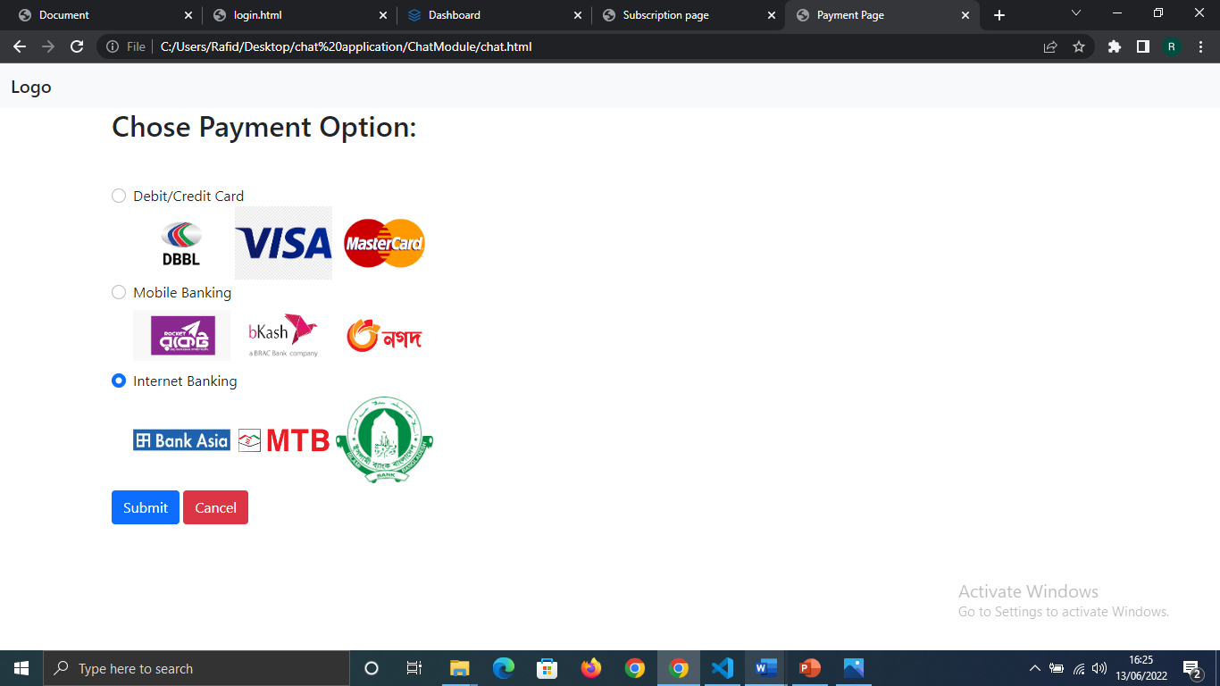

This was most of the work we performed during our three-month internship. Also, we did attend hardware classes.

**Final Outcome**

After this chat application is fully developed users will be able to chat with one another. The speciality of this chat application is that it is light-weight and has a beautiful looking, easy to use Graphical User Interface. The chat application is also very secure has it has login and signup verification. Initially it will be used for internal purposed of Grameen Communication and later, be released as a commercial software.

**Conclusion**

After successful completion of this internship, we have got used to the office culture. We know how to better manage and handle a project in teams. We have got far better in time management and communication skills.

This experience that we have gathered during the internship will help us further in our future careers for finding jobs and working in corporate places.